* **MATERIAL PARAMETERS:**

λ = 0.103

κ = 0.01

e0 = 0.7

M = 1.2

ν = 0.3

pR  = 98.0

gs = 20000

* **ISOTROPIC TEST**

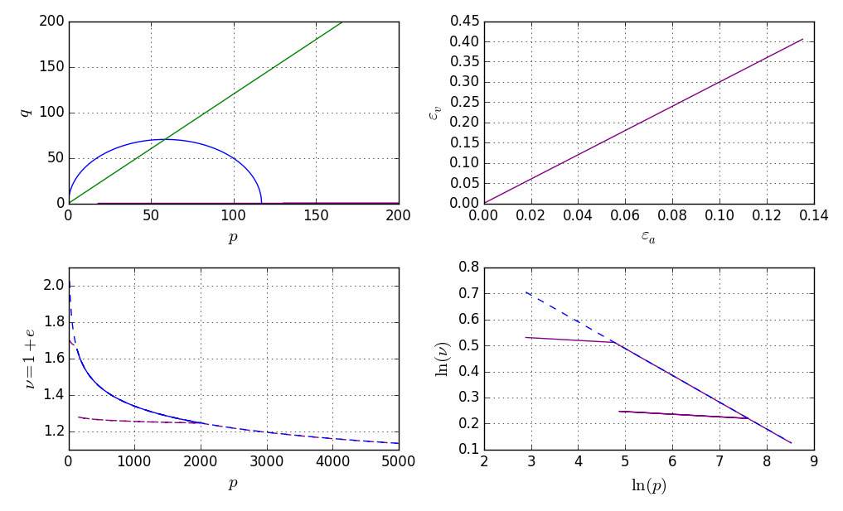

* **CU TEST**

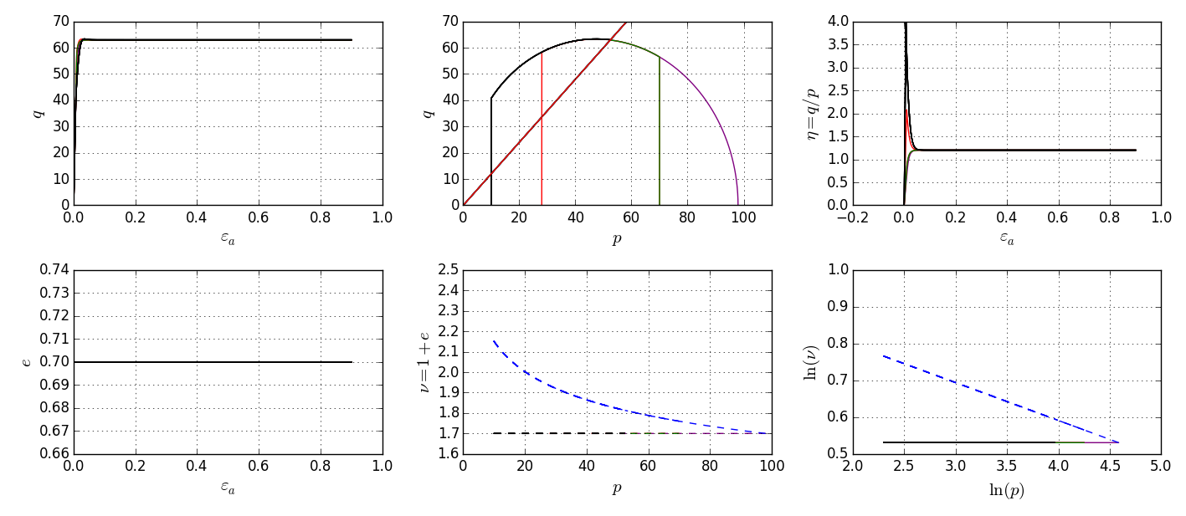

* **CD TEST**

